Lesson 04 Demo 07

Runtime Information About the VM

Objective: To obtain runtime information about the VM
Tools Required: None

Prerequisites: Virtual Machine, Azure CLI

Steps to be followed:
- Listing VMs
- Getting IP Address and detailed VM information

Step 1: Listing VMs

- Login to Azure CLI by running the az login command

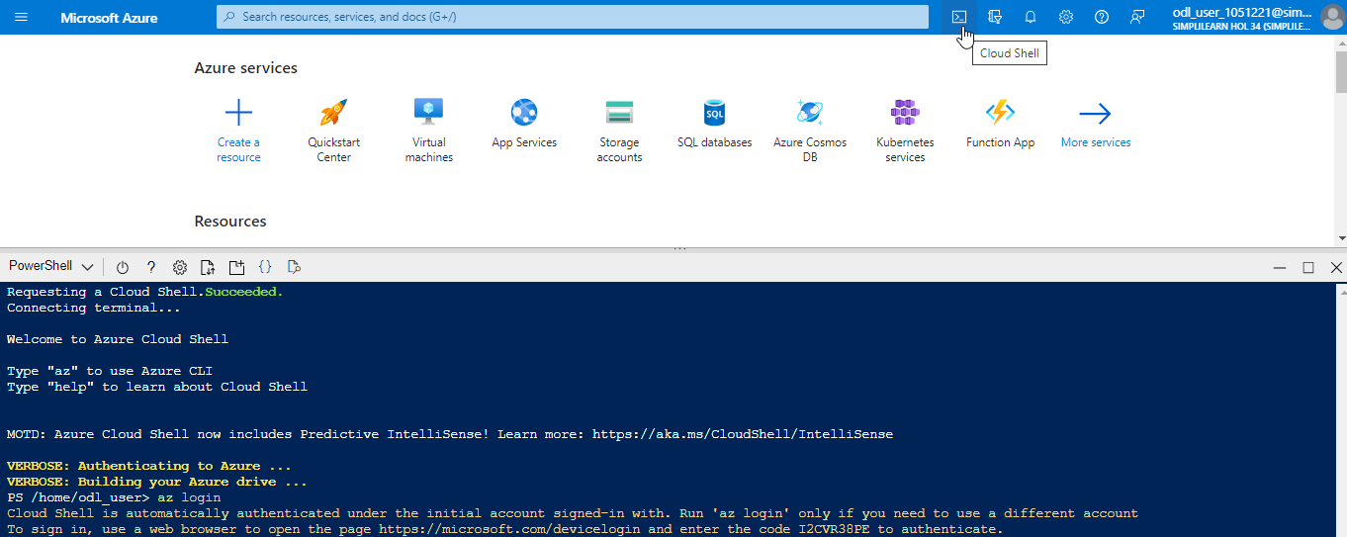

- A link accompanied by a code appears; clicking on the link redirects to a page where the code must be entered. After entering the code, a login page appears. Once login is done successfully, this output is displayed:

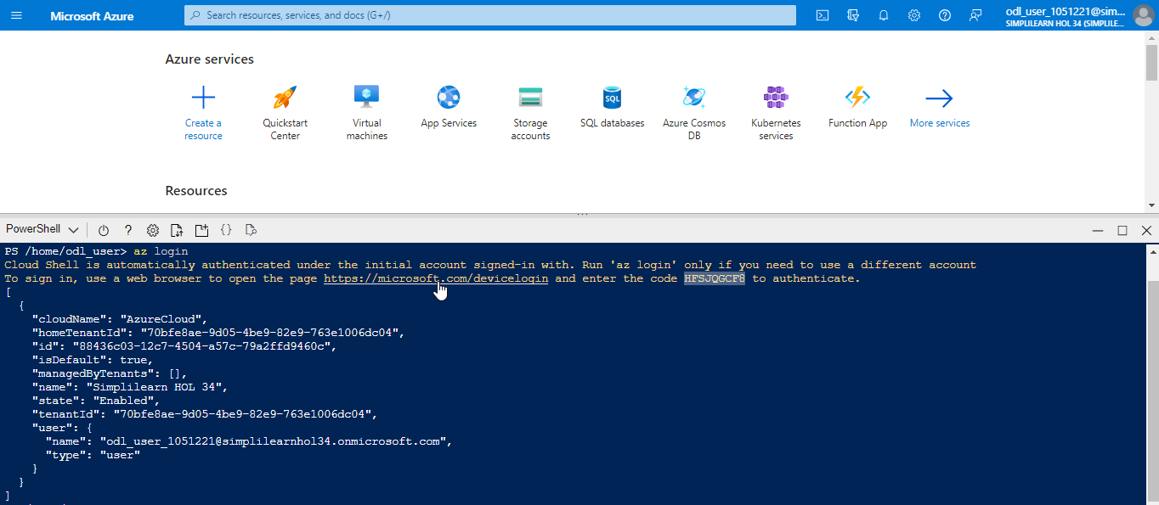

- Run the command az vm list --output table to list all the VMs defined in the subscription

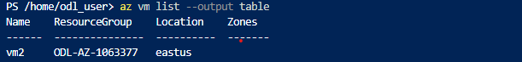

Step 2: Getting the IP Address and detailed VM information

  - Run the command az vm list-ip-addresses -n <vm name>-o table to list the public and private IP addresses of the VM

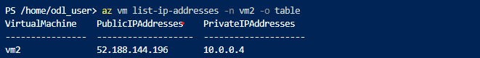

  - Run the command az vm show --resource-group <resourcegroup name> --name <vm name> to get more detailed information about the VM

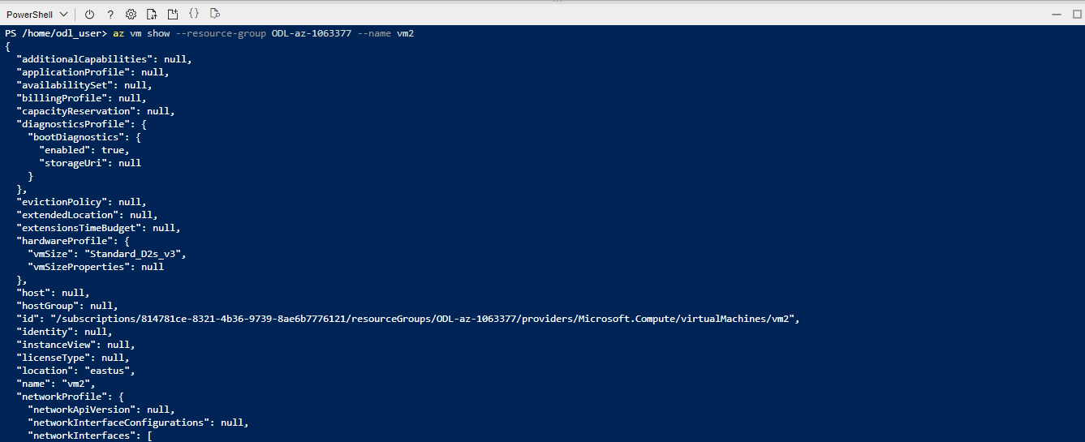

You have successfully fetched the information about the virtual machine.

